**P.E.C**

**Project Deliverable-01**

Submitted to:

Ma’am Amna Mirza

Submitted by:

Laiba Noor Ali (BSEF19A011)

Ramsha Mehmood (BSEF19A031)

Muqaddas Rasheed (BSEF19A037



**P.U.C.I.T**

**Design Class Diagram**

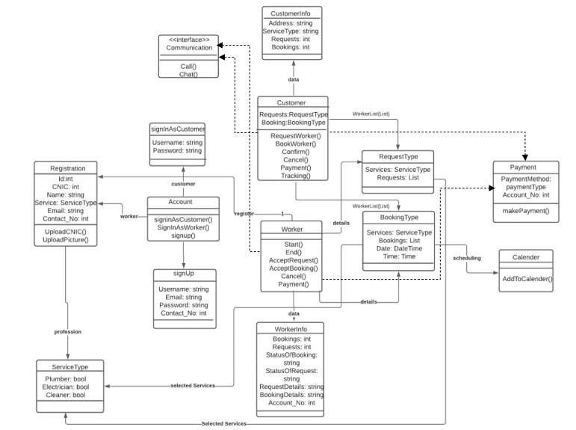

**System Sequence Diagrams**

Customer:

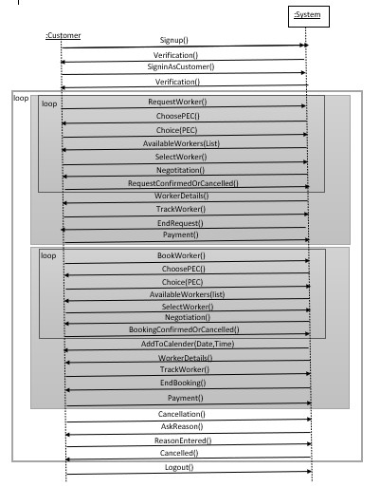

Worker:

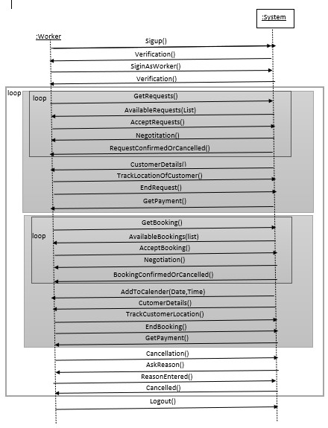

**Sequence Diagrams for Customer**

Sign-Up:

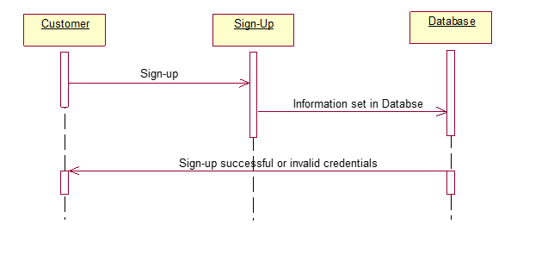

Sign-In:

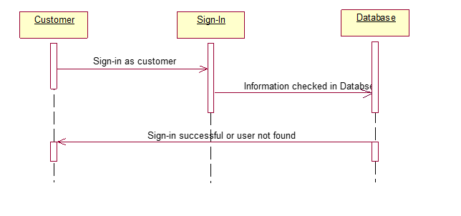

Sign-Out:

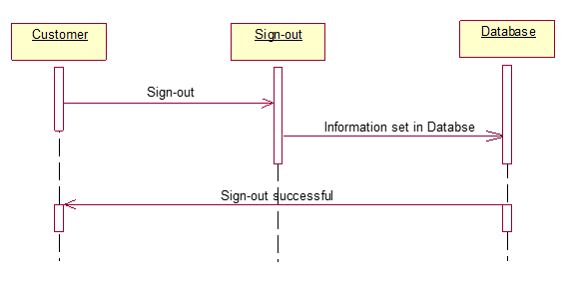

Request a worker:



Book a worker:



**Sequence diagrams for worker**

Sign-Up:

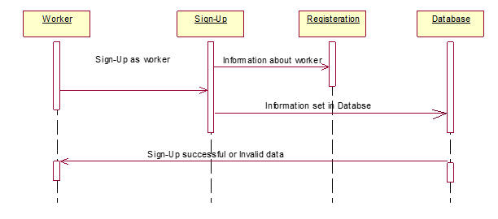

Sign-In:

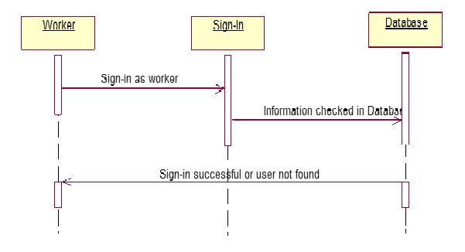

Registration:



Accept booking:



Accept request:



Sign-Out:

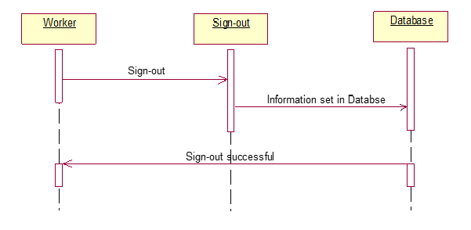

**Collaboration diagrams for customer**

Sign-Up:



Sign-In:



Request a worker:



Request a booking:



Sign-Out:



**Collaboration diagrams for worker:**

Sign-Up:



Sign-In:



Registration:



Accept request:



Accept booking:



Sign-Out:



**Architecture**

MVC is used as an architecture in our application. Following is the MVC use case diagram.

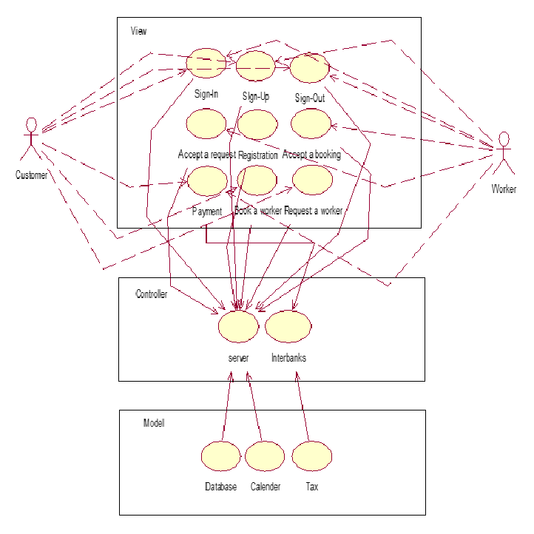

**Prototype from Customer side**

Step wise images have been added.

 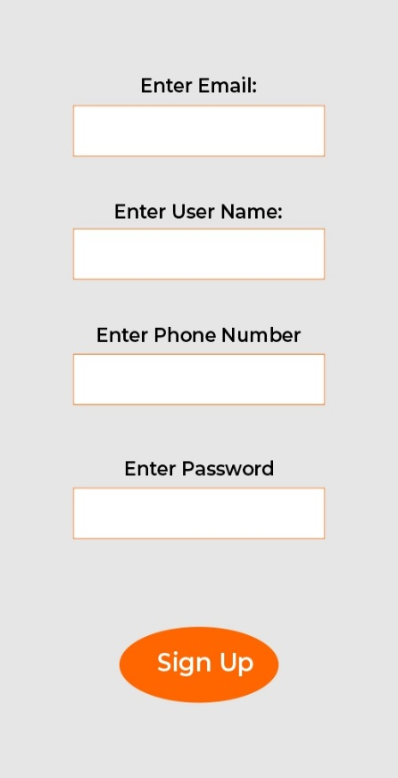

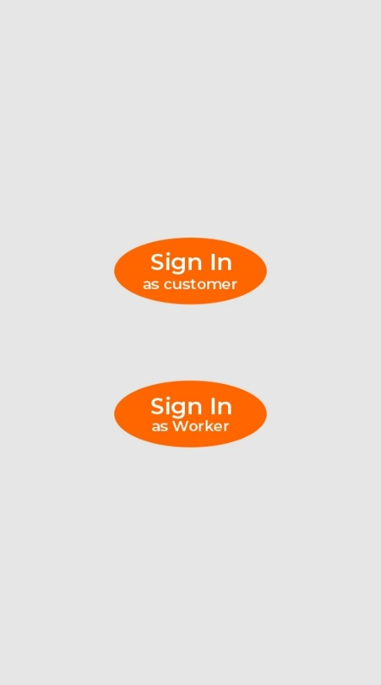 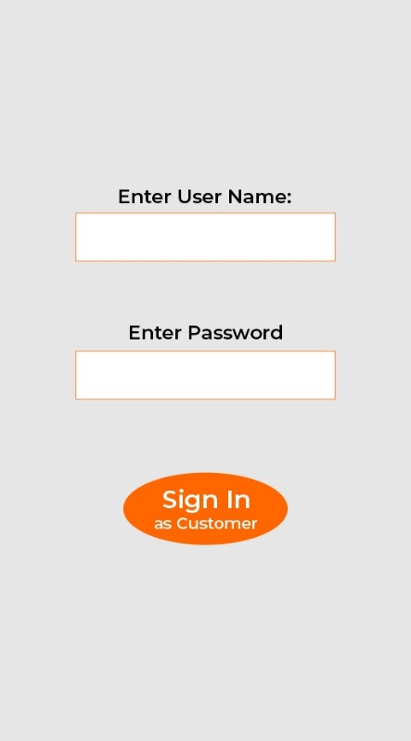

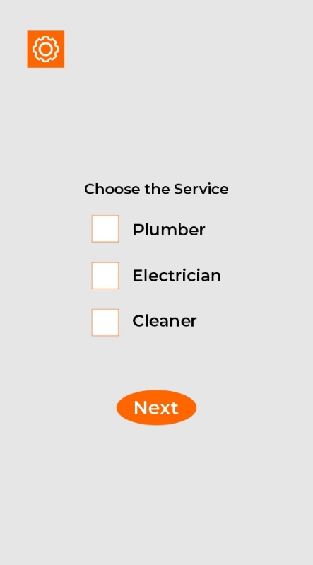 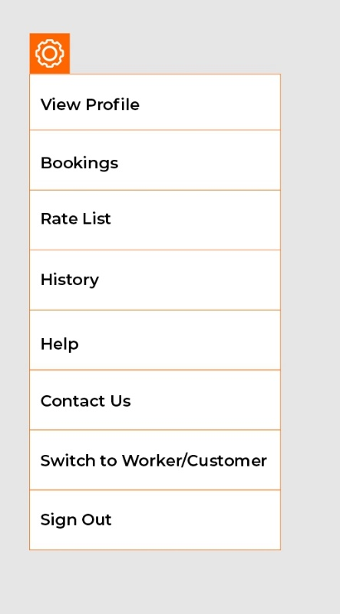

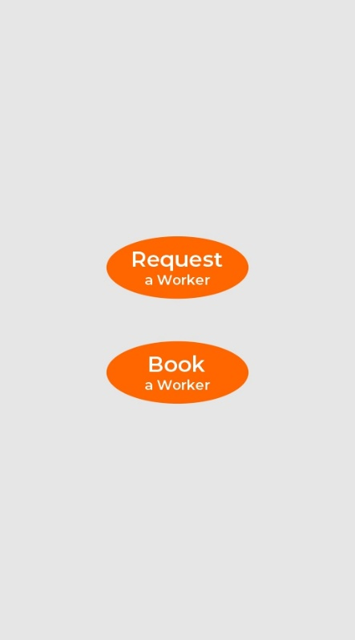 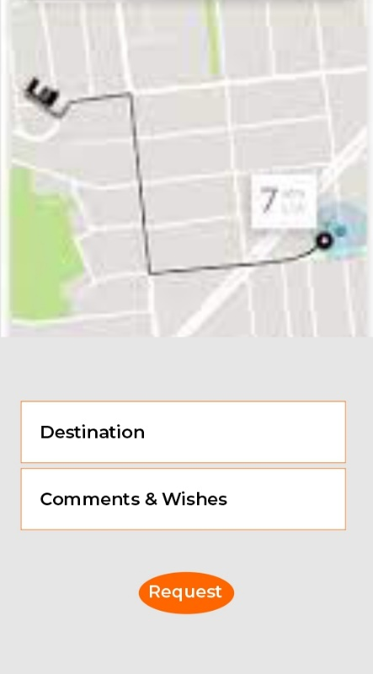

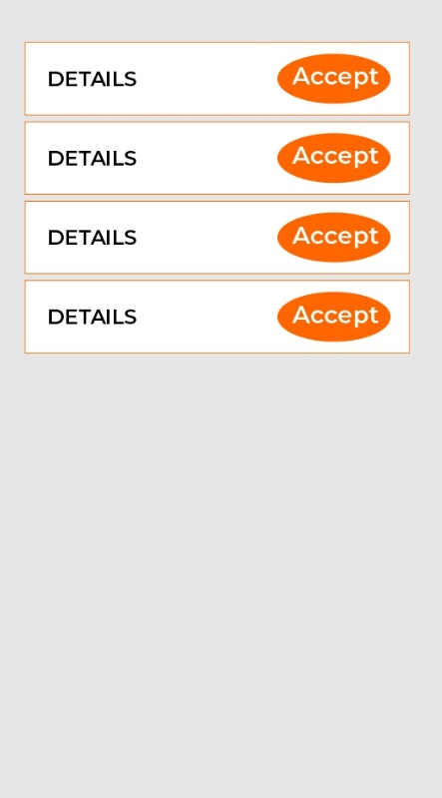 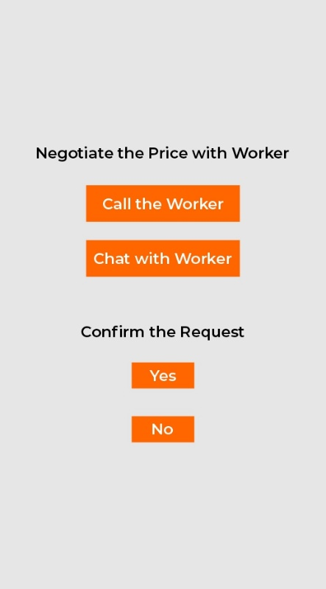

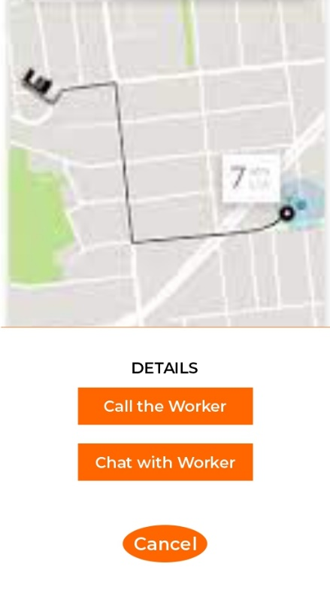 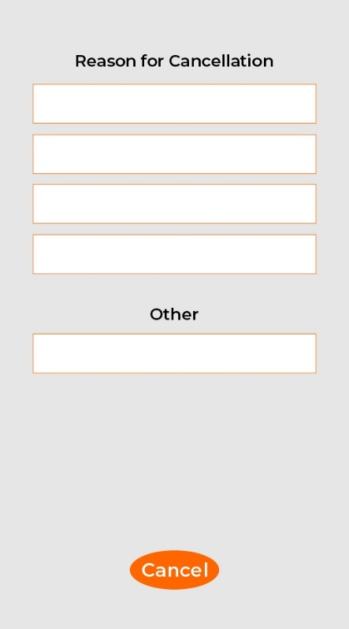

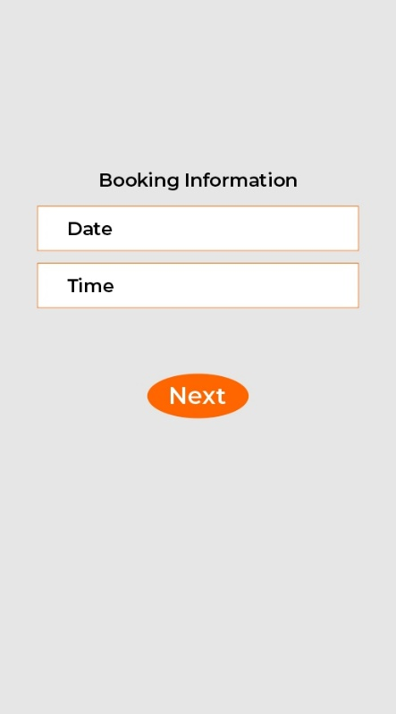

**Prototype from Worker side**

Step wise images have been added.

 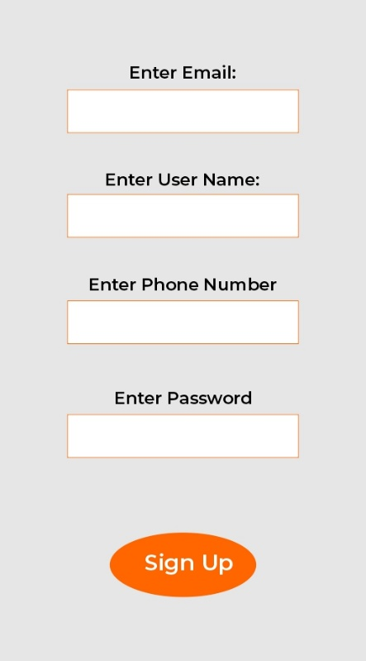

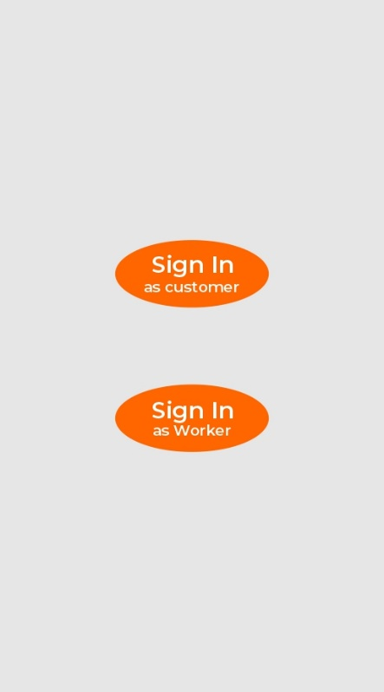 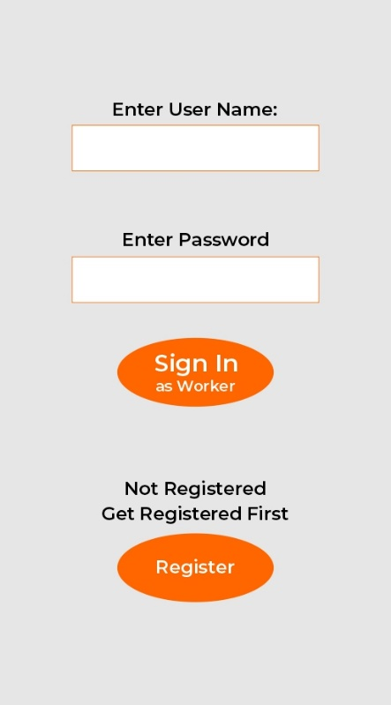

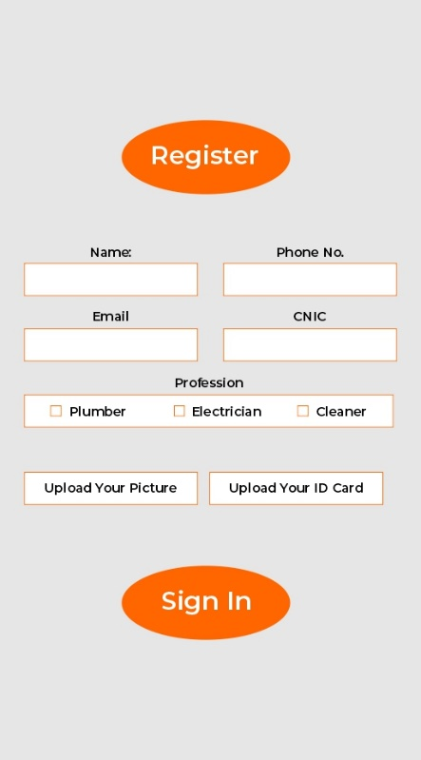 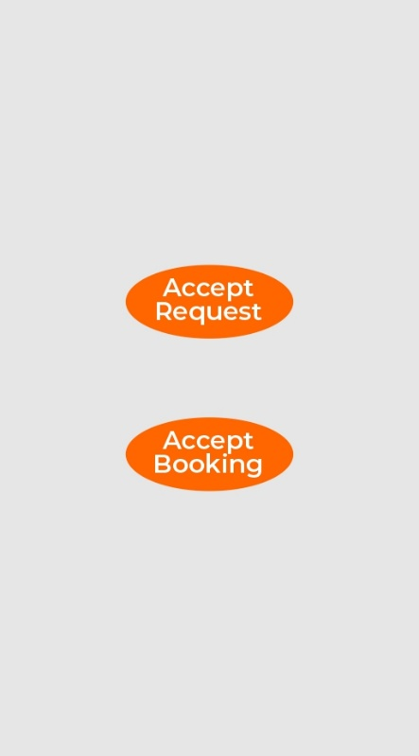

 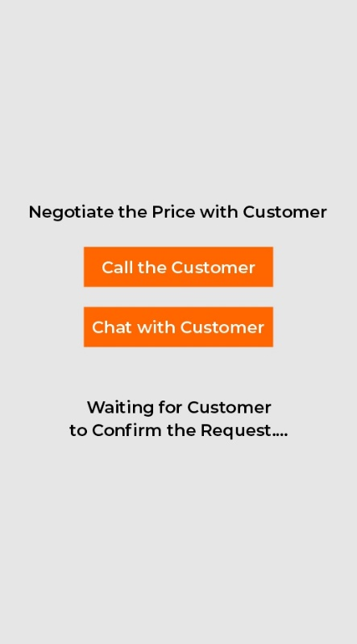

 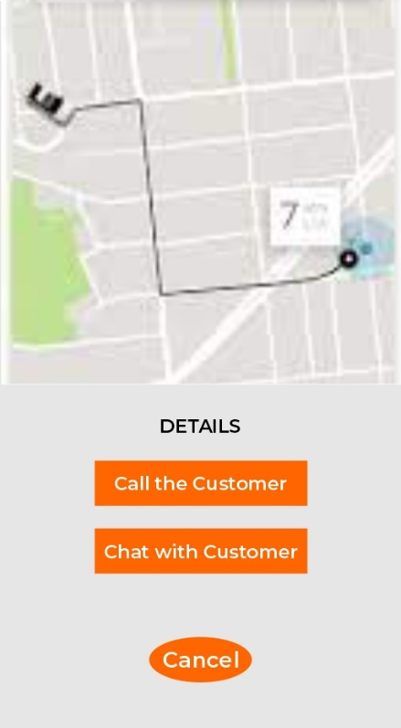

**Use Case Contracts**

Primary Actors:

* Customer
* Worker

**Customer:**

1. **Use case:** Sign-in

**Primary actor:** Customer

**Pre-condition:** Customer is authorized to login to his/her account.

**Scenario:** Customer login to his/her account. He/she will enter his/her credentials and will sign-in. Then the system displays his/her account and requests/bookings are enabled.

**Post-condition:** Sign-in operation is successfully ended and he/she is able to request/book a worker.

1. **Use case:** Sign-up

**Primary actor:** Customer

**Pre-condition:** Customer is authorized to make a new account.

**Scenario:** He/she will enter his/her credentials and will sign-up. Then the system will require sign-in to proceed with the application.

**Post-condition:** Sign-out operation is successfully ended.

1. **Use case:** Sign-out

**Primary actor:** Customer

**Pre-condition:** Customer has an account.

**Scenario:**  After Signing-out, application will be signed-out.

**Post-condition:** Sign-out operation is successfully ended.

1. **Use case:** Requesting a worker

**Primary actor:** Customer

**Pre-condition:** Customer has an account

**Scenario:** The user will select whether he wants a plumber, electrician or a cleaner, then select the required service and press request a worker. Then the Customer will be directed to the requests page where he could select the available worker and negotiate with the worker upon payment. The user will be then asked to confirm the request. The user will be notified with a pop-up notification that the worker is on his way and the user can track the worker.

**Post-condition:** Service ended successfully.

1. **Use case:** Booking a worker

**Primary actor:** Customer

**Pre-condition:** Customer has an account.

**Scenario:**  Customer will select whether he wants a plumber, electrician or a cleaner, then select the required service and press book a worker. After hiring any worker, customer will be then asked to confirm the booking. When the time would come the user will be notified with a pop-up notification that the worker is on his way and the user can track the worker. Once the payment is cleared, user will be asked to rate the worker.

**Post-condition:** Service ended successfully.

**Worker:**

1. **Use case:** Registration

**Primary actor:** Worker

**Pre-condition:** Worker will be authorized to fill out a form asking for certain information to get registered.

**Scenario:**  After registering, the worker makes its account on P.E.C. Then the system displays its account and he/she will be able to take the customers’ requests.

**Post-condition:** The worker’s Registration operation is successfully ended.

1. **Use case:** Sign-in

**Primary actor:** Worker

**Pre-condition:** Worker is authorized to login to his/her account.

**Scenario:** Customer login to his/her account. He/she will enter his/her credentials and will sign-in. Then the system displays his/her account and requests/bookings acceptance is enabled.

**Post-condition:** Sign-in operation is successfully ended.

1. **Use case:** Sign-up

**Primary actor:** Worker

**Pre-condition:** Worker is authorized to make a new account after Registering him/herself.

**Scenario:** He/she will enter his/her credentials and will sign-in. Then the system displays his/her account and he/she will be able to accept requests/bookings from a worker.

**Post-condition:** Sign-out operation is successfully ended.

1. **Use case:** Sign-out

**Primary actor:** Worker

**Pre-condition:** Worker has an account.

**Scenario:** After Signing-out, application will be signed-out.

**Post-condition:** Worker signed-out successfully.

1. **Use case:** Accept Request

**Primary actor:** Worker

**Pre-condition:** Worker is authorized to accept the customer’s requests.

**Scenario:**  If the location is not on, worker will be asked to turn on his location so that only the requests in his area are popped-up on the screen. Then he can select between these requests and negotiate with the customer regarding the payment. Once the customer confirms the request, worker will be directed towards user destination.

**Post-condition:** After customer ends the request, worker will be directed to the requests page. And in this way, the operation is successfully ended.

1. **Use case:** Accept Booking

**Primary actor:** Worker

**Pre-condition:** Worker is authorized to accept the customer’s booking requests.

**Scenario:**  If the location is not on, worker will be asked to turn on his location so that only the bookings in his area are popped-up on the screen. Then he can select between these requests and negotiate with the customer regarding the timing and the payment. Once the customer confirms the booking the worker will be requested to add the date and timing of the booking so that he can be notified when the time would come and when the worker selects that he is on his way he will be directed towards user destination.

**Post-condition:** After the customer ends the booking process then the worker’s operation is successfully ended.